Hollydale Physical Education

Hollydale Physical Education Resources for Home

Did you know that you need to get 60 minutes of physical activity each day? It is easy to get those 60 minutes of activity a day by remembering, it does not have to be completed at one time. Try moving in small chunks of time, several times a day. Below you will find a number of links and ideas to get your 60 minutes of moving in each day. Try a variety of these activities while you are home.
Time to get active, get outside and enjoy the sun (if it ever stops raining). Have your parents join you to make the most of an active week(s). Try these different activities when you’re at home. Make sure to get parent permission if you are moving inside your house and as always, BE SAFE!
- Skip, gallop and run - participate in a locomotor skill around you house or back yard. (Skip for the first lap, gallop the 2nd and run laps 3 and 4, repeats 4 times)
- Jump Rope or Hula Hoop for 5 minutes. Don't have jump rope or hula hoop? Use an imaginary rope and jump.
- Take a walk in your neighborhood with your family.
- Do 100 Jumping Jacks and then take your pulse; rest 5 minutes and check it again. Did it go up or down? Here is how you can check your pulse. Put your thumb on your chin and your index (or pointer) finger on your neck where you can feel your pulse. Have your parents or sibling time you for 6 seconds, then add a zero. For example if you got 9; your pulse rate would be 90.
- Play throw and catch with Frisbee, baseball, softball or playground ball for 30 minutes.
- Play basketball, wiffleball, football, or tag for 30 minutes outside with parent or sibling.
- If it rains, turn on music and have a dance party!
- Create your own game or activity. _________________________________
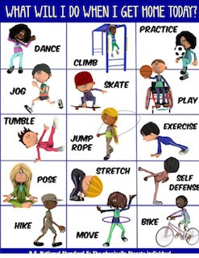

Try these websites for some movement

Websites for Physical Activity
 | Activity
Tabata Fitness | https://www.physeddepot.com/jlaavengers-tabata-videos.html
GoNoodle | https://www.gonoodle.com/?disable_redirect=true
Just Dance Kids | https://www.youtube.com/results?search_query=Just+Dance+kids
Move to Learn | http://www.movetolearnms.org/how-do-i-do-it/
Intelliboost | www.intelleboost.com  Username: Hollydale Password: cobbk12
OPEN  Online Physical Education Network | https://openphysed.org/activeschools/activehome
Adventure 2 Learn | https://www.adventure2learning.com/sample-videos
Cosmic Kids Yoga | https://www.youtube.com/user/CosmicKidsYoga

