Week 2 | Monday | Tuesday | Wednesday | Thursday | Friday
Reading | -Read book of choice for 20 min and complete written response for that day OR get on Systems 44, Headsprouts, MobyMax reading.  -Daily Common Core ELA Practice Week 2 Monday  (40 Minutes) | Read book of choice for 20 min and complete written response for that day OR get on Systems 44, Headsprouts, MobyMax reading.  -Daily Common Core ELA Practice Week 2 Tuesday  (40 Minutes) | Read book of choice for 20 min and complete written response for that day OR get on Systems 44, Headsprouts, MobyMax reading.  -Daily Common Core ELA Practice Week 2 Wednesday  (40 Minutes) | Read book of choice for 20 min and complete written response for that day OR get on Systems 44, Headsprouts, MobyMax reading.  -Daily Common Core ELA Practice Week 2 Thursday  (40 Minutes) | Read book of choice for 20 min and complete written response for that day OR get on Systems 44, Headsprouts, MobyMax reading.  -Daily Common Core ELA Practice Week 2 Friday  (40 Minutes)
Writing | Soccer Tryouts in packet  RACE  (15 min) | RACE writing  Emojis under week plans  (15 min) | RACE writing  Amazing Dogs under week plans  (15 min) | RACE writing  Karate Kid under week plans  (15 min) | RACE writing  Your Delivery is Here under week plans  (15 min)
Math | - Zearn or Prodigy for 20 minutes  - Cookie Problem in packet  - Color and Compare Like Fractions in packet  (45 min) | - Zearn or Prodigy for 20 minutes  - Zoo Area/Perimeter Project under week plans  Area: L x W  Perimeter:  L + L + W + W  PeRIMeter – outside of shape  Area – inside of shape – labeled square units  - Number line Fractions in packet (45 min) | - Zearn or Prodigy for 20 minutes  - Zoo Area/Perimeter Project under week plans  - 2nd page of number line fractions in packet (45 min) | - Zearn or Prodigy for 20 minutes  -KWL word Problem:  Mr. W is going to read 8 pages a day. He has already read 26 pages. How many more days will need to read to finish the 92 page book?  -Comparing Fractions Lesson 12 in packet (45 min) | - Zearn or Prodigy for 20 minutes  -KWL word problem:  Ansley has 59 stickers. She shares 17 with her mom and then divides the rest evenly among 6 friends. How many stickers does each friend get?  - Lesson 14 (2 pages in packet)  (45 min)
Science/  Social Studies | (15 min)  Holi under week plans | (15 min)  Geography under week plans | (15 min)  Colonization  under week plans | (15 min)  New England Colonies under week plans | (15 min)  Mid-Atlantic Colonies under week plans
Social Emotional Learning | Tell a family member what L.E.A.D stand for at Hollydale?  (5 min) | Discuss with someone how you can continue to make sure you LEARN at home?  (5 min) | Discuss with someone how you can empower others while at home?  (5 min) | Discuss with someone how you can make sure you can ACHIEVE GOALS at home?  (5 min) | Discuss with someone how you can DISCOVER YOUR POTENTIAL at home?  (5 min)
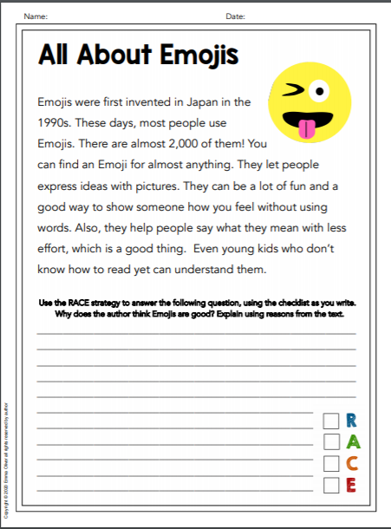

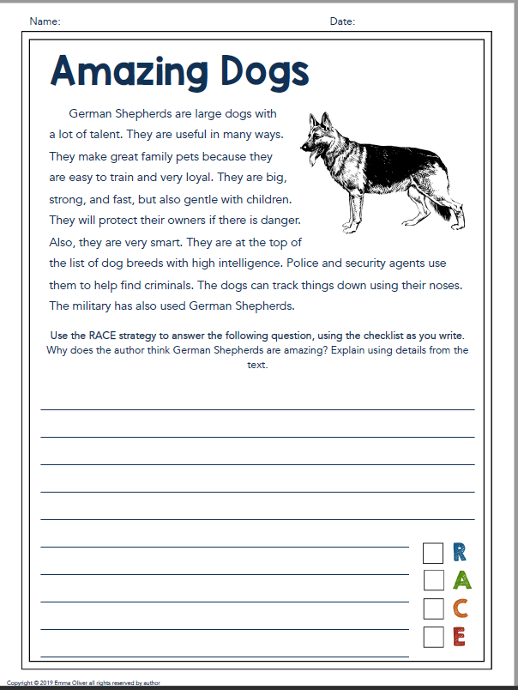
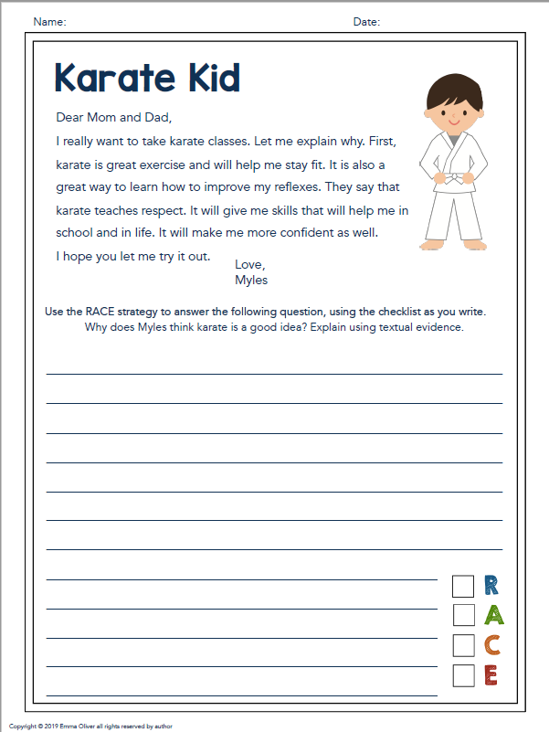
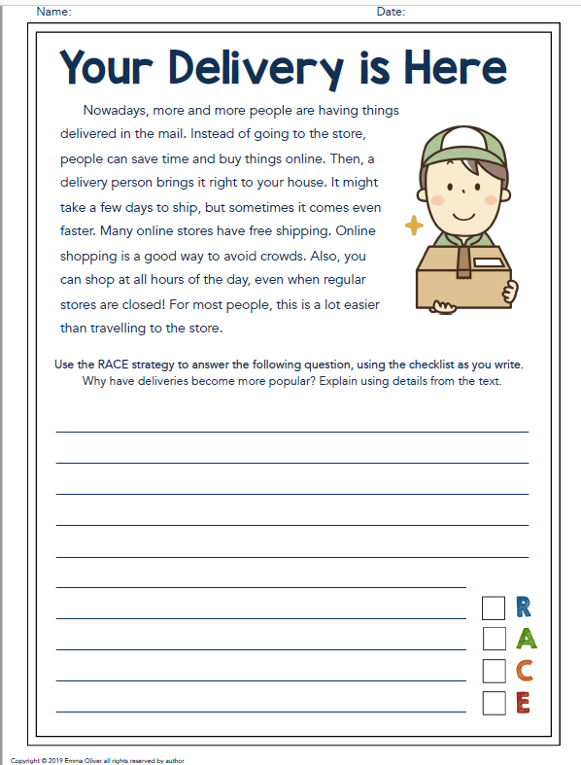
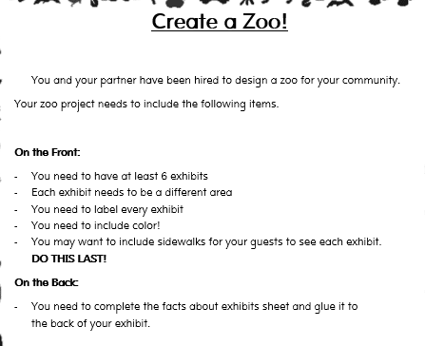
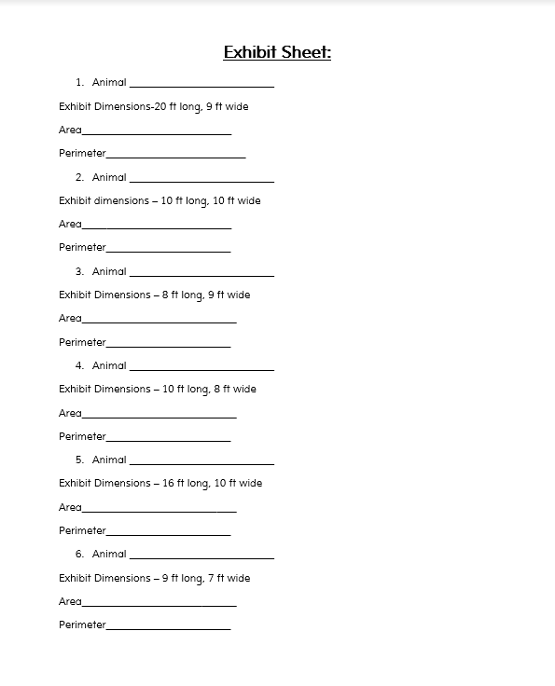

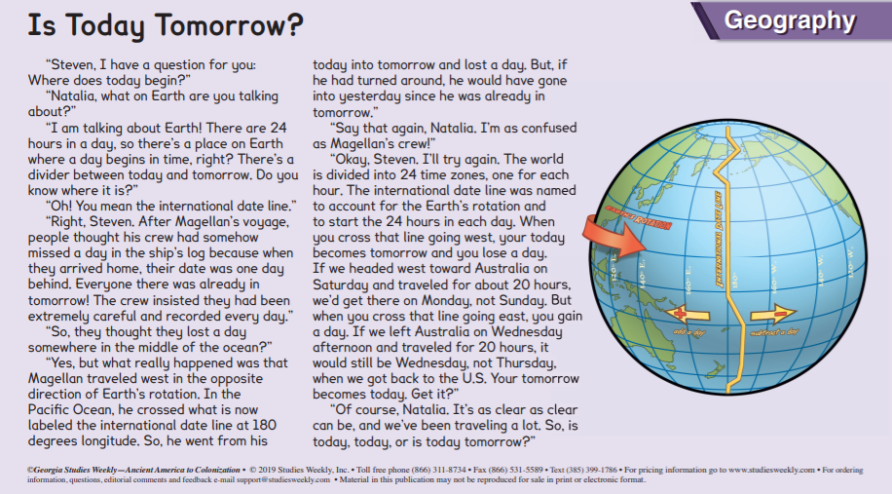
How did we discover the international date line?
Why is it important?
What is Holi?
What is an important aspect of Holi?

