Week 4 | Monday | Tuesday | Wednesday | Thursday | Friday
Reading | -Read book of choice for 20 min and complete written response for that day OR get on Systems 44, Headsprouts, MobyMax reading.  -Daily Common Core ELA Practice Week 4 Monday  (40 Minutes) | Read book of choice for 20 min and complete written response for that day OR get on Systems 44, Headsprouts, MobyMax reading.  -Daily Common Core ELA Practice Week 4 Tuesday  (40 Minutes) | Read book of choice for 20 min and complete written response for that day OR get on Systems 44, Headsprouts, MobyMax reading.  -Daily Common Core ELA Practice Week 4 Wednesday  (40 Minutes) | Read book of choice for 20 min and complete written response for that day OR get on Systems 44, Headsprouts, MobyMax reading.  -Daily Common Core ELA Practice Week 4 Thursday  (40 Minutes) | Read book of choice for 20 min and complete written response for that day OR get on Systems 44, Headsprouts, MobyMax reading.  -Daily Common Core ELA Practice Week 4 Friday  (40 Minutes)
Writing | (15 min)  Write an informational, narrative, or opinion piece on the picture of the week  *Picture is underneath the plans  *Writing genre posters below | (15 min)  Continue writing/typing an info/opinion/narrative piece  - Edit and revise | (15 min)  Continue writing/typing an info/opinion/narrative piece  - Edit and revise | (15 min)  Continue writing/typing an info/opinion/narrative piece  - Edit and revise | Catch up day  -turn in final draft through DOJO or email. You may take a picture of your writing and send in.
Math | - Zearn 15 min  -Prodigy for 10 minutes  - KWL word problem:  There are 4 birds, 2 people, and 5 dogs living in a house. How many total legs are in the house?  Get on Flocabulary for time  (45 min) | - Z Zearn 15 min  -Prodigy for 10 minutes  -KWL word problem:  There is a jar of jelly beans. Mrs. Gamel ate 15 of them and Mrs. Biedermann ate 24 of them. There are still 199 left. How many jelly beans were in the jar before they ate some?  Get on Flocabulary for time  (45 min) | - Zearn 15 min  -Prodigy for 10 minutes  - KWL word problem:  Max bought a bag of chips for $2 and 3 bags of candy for $4 a each. How much money did Max spend?  Get on flocabulary for time  (45 min) | - Zearn 15 min  - Prodigy for 10 minutes  -KWL word Problem: Brandon had 7 bags of stuffed animals. Each bag had 8 stuffed animals in it. He then gave away 12 of them. How many stuffed animals does he have now?  Get on Flocabulary for time  (45 min) | Catch up day
Science/  Social Studies  13 colonies | Read Mid-Atlantic: The Quakers and answer question using RACE  Under Lesson Plans  (15 min) | Read Life in the Mid Atlantic Colonies and answer question using RACE.  Under Lesson Plans  (15 min) | Read Mid Atlantic Resources and Economy and answer question using RACE.  Under Lesson Plans  (15 min) | Use Mid Atlantic graphic organizer to talk about life in the Mid Atlantic colonies.  Under Lesson Plans  (15 min) | Catch up day
Social Emotional Learning | Explain to a family member what it means to Put first things first.  (5 min) | How can you put first things first during these digital learning days?  (5 min) | Explain to a family member what think win-win means.  (5 min) | How can you think win-win during these digital learning days?  (5 min) | Sharpen the saw!

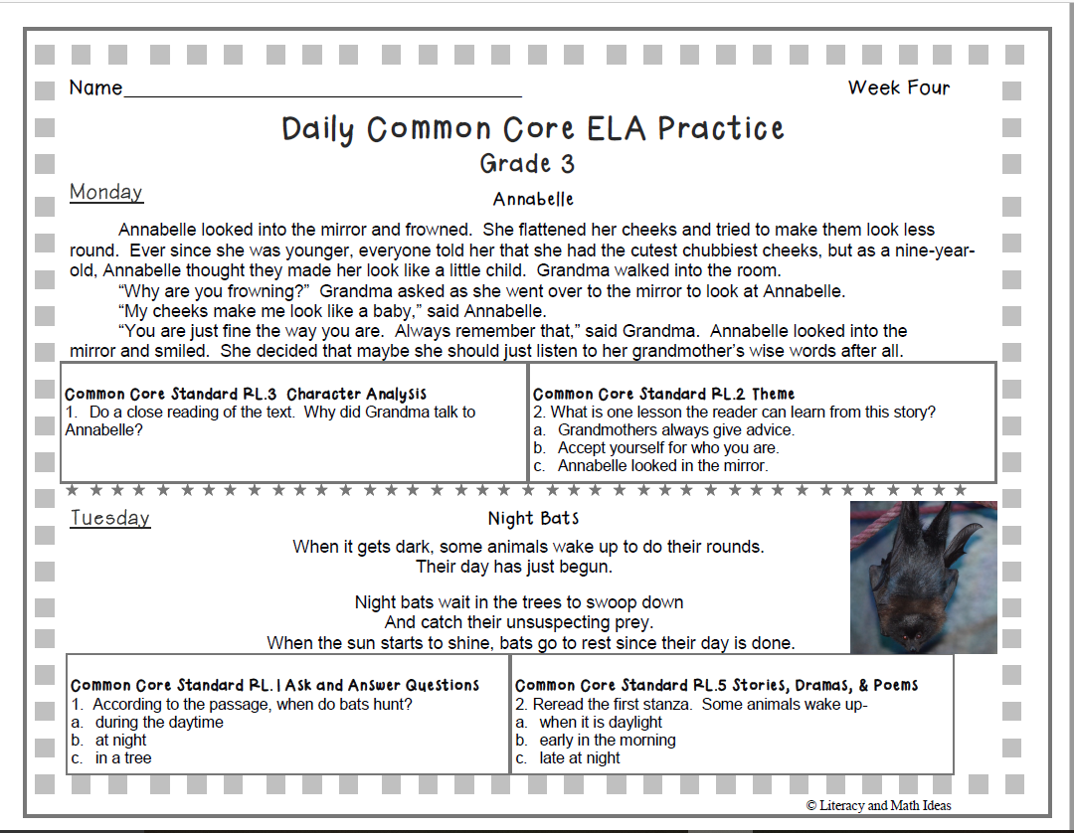

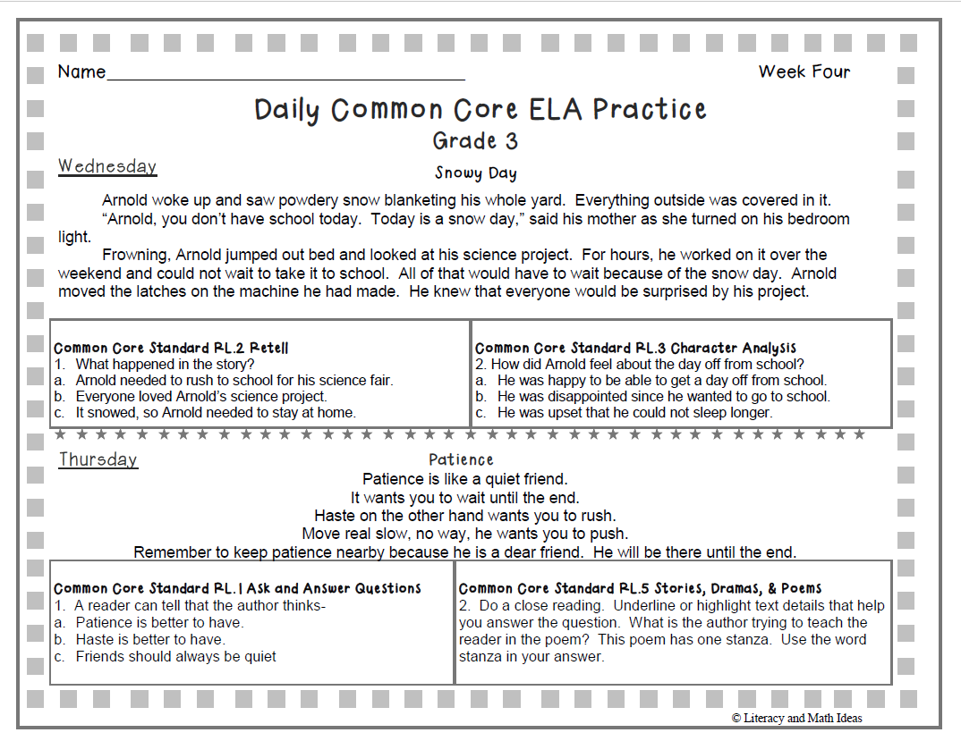

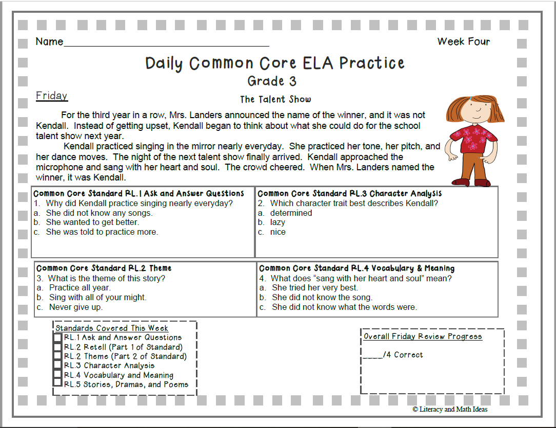

Writing - Picture of the Week

