Week 7 | Monday | Tuesday | Wednesday | Thursday | Friday
Reading | -Read book of choice for 20 min and complete written response for that day OR get on Systems 44, Headsprouts, MobyMax reading.  -Daily Common Core ELA Practice Week 7 Monday  (30 Minutes) | Read book of choice for 20 min and complete written response for that day OR get on Systems 44, Headsprouts, MobyMax reading.  -Daily Common Core ELA Practice Week 7 Tuesday  (30 Minutes) | Read book of choice for 20 min and complete written response for that day OR get on Systems 44, Headsprouts, MobyMax reading.  -Daily Common Core ELA Practice Week 7  Wednesday(30 Minutes) | Read book of choice for 20 min and complete written response for that day OR get on Systems 44, Headsprouts, MobyMax reading.  -Daily Common Core ELA Practice Week 7 Thursday  (30 Minutes) | -Daily Common Core ELA Practice Week 7 Friday  Catch up day  (40 Minutes)
Writing | Write an informational, narrative, or opinion piece on the picture of the week  *Picture is underneath the plans  *Writing genre posters below  (20 min) | Would you rather be able to read minds or be able to turn invisible? Write your opinion on which and WHY. Provide Reasons.  (20 min) | Write an informational paper on your favorite video game or tv show.  (20 min) | Write a narrative about the best birthday you ever had.  (20 min) | Catch up day
Math | - Zearn 15 and Prodigy for 15 minutes  -COTTON CANDY PACKET  Questions 1-4  (45 min) | - Zearn 15 and Prodigy for 15 minutes  -COTTON CANDY PACKET  Questions 5-8  (45 min) | - Zearn 15 and Prodigy for 15 minutes  -COTTON CANDY PACKET  Questions 9-12  (45 min) | - Zearn 15 and Prodigy for 15 minutes  -COTTON CANDY PACKET  Questions 13-17  (45 min) | Catch up day
Miscellaneous | Complete a Flocabulary Lesson  (20 min) | Complete a Flocabulary Lesson | Complete a Flocabulary Lesson  (20 min) | Complete a Flocabulary Lesson  (20 min) | Catch up day
Social Emotional Learning | Read a book with a family member | Play a game outside (hide and seek, kickball) | Clean your room then relax in it | Eat dinner with your family. | Sharpen the saw!

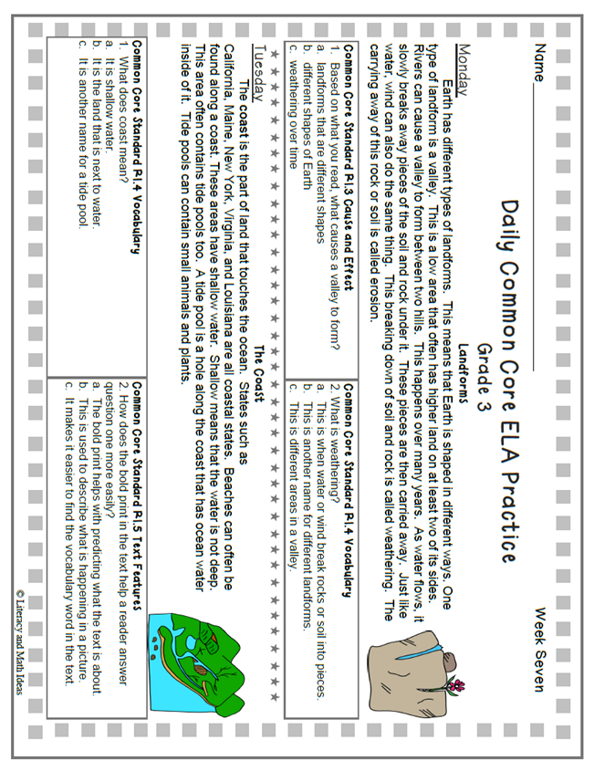

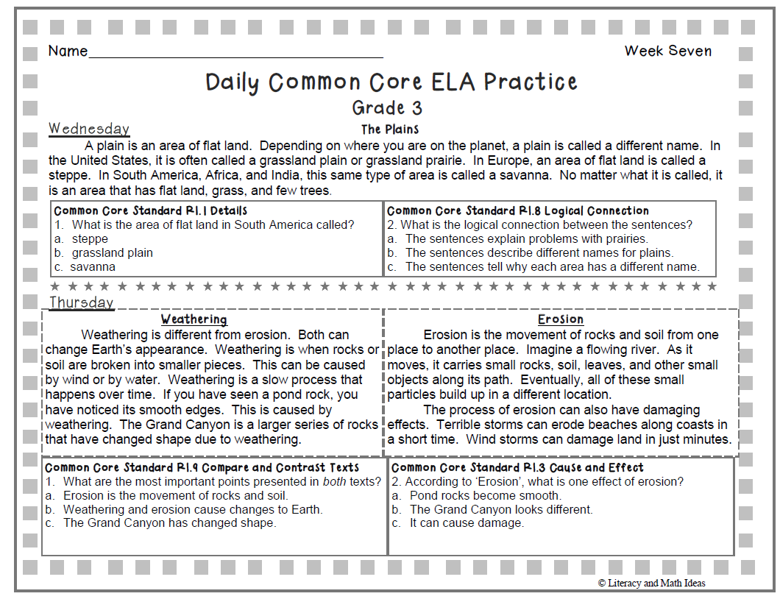
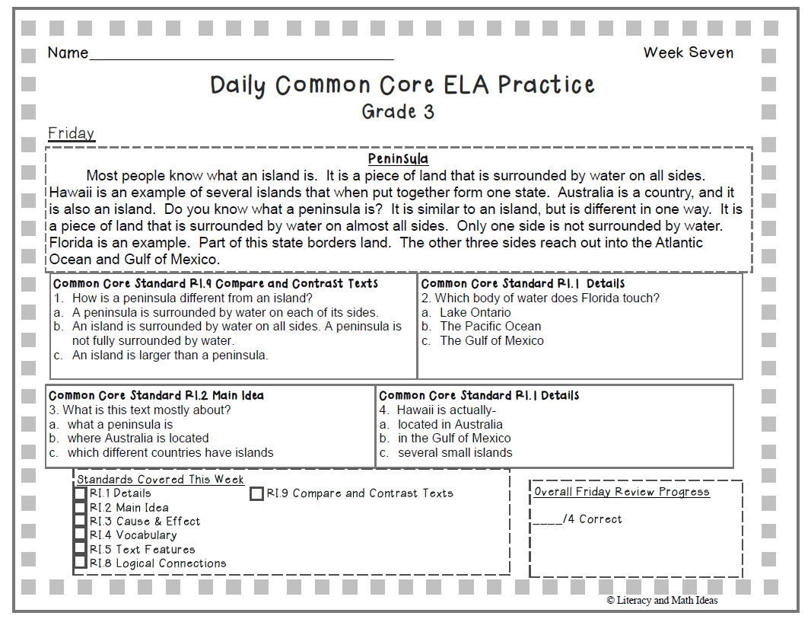

Picture for Monday’s writing

